Practical 6:
Aim:
To implement stack using array and linked list, and apply stack-based logic to expression
conversion, evaluation, and bracket validation problems.
Problem 1
A cafeteria stacks clean trays on a fixed-size counter. New trays are always placed on top, and
customers always take from the top. The counter can hold at most n trays at a time — if it is full,
no more trays can be added, and if it is empty, no tray can be taken. Given a sequence of place
and take operations, implement this fixed-capacity tray stack and print the current top tray after
each operation. Report an error if a place or take operation cannot be performed.
Describe how your solution tracks whether the stack is full or empty. What are the exact
conditions you check before a push and before a pop, and what does your program do when
those conditions fail?
Problem 2
A web browser keeps track of pages visited so that the back button always returns to the most
recently visited page. Unlike a fixed counter, the browser has no hard limit on how many pages
it can remember — it grows as the user visits more pages and shrinks as they press back.
Given a sequence of visit and back operations, implement this unlimited page history and print
the current page after each operation.
Describe how your solution differs from Problem 1 in how it handles memory. What happens in
your solution when the user presses back on the very first page with no history left?

Problem 3
A calculator application receives arithmetic expressions typed by users in the usual way —
numbers and operators written in between, with brackets to control priority (e.g. 3 + 4 * 2 or (3 +
4) * 2). Internally the calculator needs to convert each expression into a form where operators
appear after their operands, so it can evaluate them without needing to re-read brackets. Given
an infix expression, convert it to the equivalent postfix form and print the result.

Describe the role the stack plays in your conversion. What does your solution do when it
encounters a closing bracket, and what happens to the operators that were waiting on the stack
at that point?
Practical-link:
https://github.com/kahanipatel156-dev/FDSA-Batch-B/tree/main/Practical%206

Screenshots:
Problem 1:
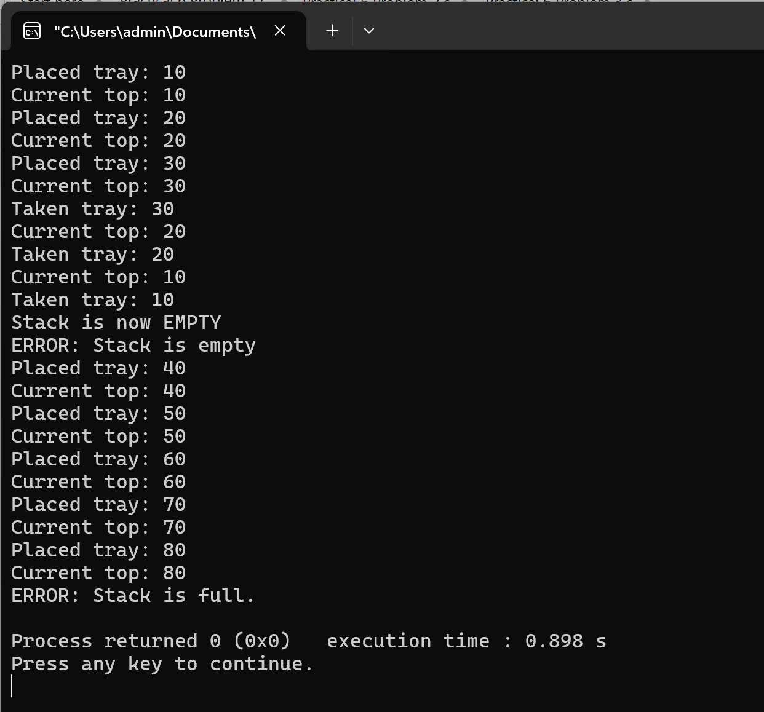

Problem-2:
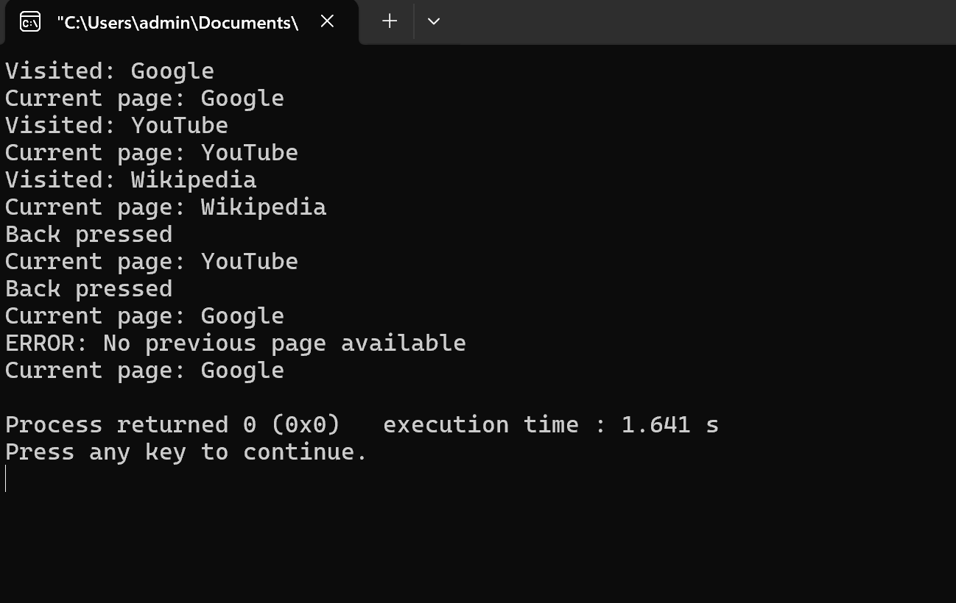

Problem-3:
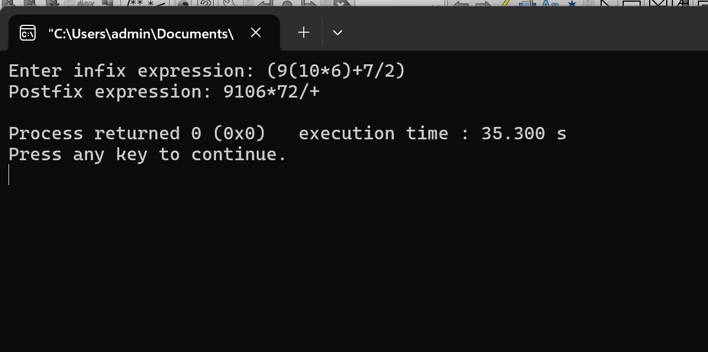
Problem-Faced:
Building of concepts and applying logic.

Learning:
Concept of stack implementation using push() and pop() operations.

